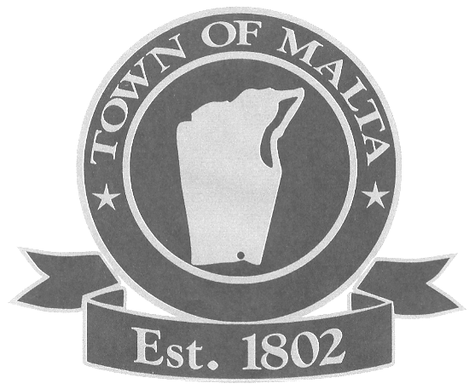
Office Use Only
Date Received_______________
Reservation Fee Received______
Cert/Insurance Received_______

MALTA COMMUNITY DAY FOOD VENDOR APPLICATION
Saturday, September 6, 2025
10:00 am - 3:00 pm
Shenantaha Creek Park
Eastline Road, Malta, New York
(518)-899-4411

Business/Vendor Name: ______________________________________________________

Contact Person: ___________________________ Date of Birth ________________

Address: ______________________________________________________

Phone: ______________________________________________________

Email Address: ______________________________________________________

Type of Food Items: _______________________________________________________

Do You Require Electricity _______________________________________________________

Welcome to the Town of Malta Community Day. This yearly event brings our community together to have fun and meet neighbors. To make this event safe for everyone, the following procedures must be followed.
- You must provide your own tables and chairs.
- Booths are to be set up by 9:30 am. Booths cannot be taken down before 3:00 pm when the event closes.
- Food items must be approved in advance by the Department of Parks & Recreation. Food that is sold must be consumable by people only.
- This application should be returned with a $50.00 non-refundable fee for a food booth.
- Space will be reserved when the application, payment (if applicable), hold harmless agreement (see below) and a certificate of insurance has been received. Food space is limited.
- Applications must be received a week prior to the event date.
- The vendor agrees to indemnify and hold harmless the Town of Malta against any and all claims, damages, losses and expenses.
- A certificate of insurance with a minimum liability amount of $1,000,000 naming the Town of Malta as additional insured must be returned with this application.
- Food vendors are responsible for following all rules and regulations regarding any food preparation and service as established by the New York State Health Department 77 Mohican Street, Glens Falls, NY 12801-4429, 518-793-3893. Allow two to four weeks to process an application.
- Not for profits without employees must fill out and submit a CE200 Certificate of Attestation of Exemption from Workers’ Compensation and/or Disability Benefits coverage on-line as part of the package (http://www.wcb.state.ny.us/content/ebiz/wc_db_exemptions/requestExemptionOverview.jsp).
- Health Department permits shall be clearly displayed in all food booths.
- A certificate of insurance with a minimum liability amount of $1,000,000 naming the Town of Malta as additional insured must be returned with this application. The Town policy is that all vendors are required to call their insurance company and request a certificate of insurance naming the Town additional insured. If someone is not insured or runs into any issues, they should call Alyssa Benway, Director of Parks & Recreation, 899-4411 X 303 to see if it can be waived. The goal is to protect the Town from loss or exposure to loss resulting from any possible negligence on the part of a vendor. This transfers any associated risks from the Town to the insurer.

TOWN OF MALTA HOLD HARMLESS AGREEMENT

By signing below, the vendor_______________________________________________________________
Name of Vendor
Agrees to indemnify and hold harmless the Town of Malta, its officers, employees, agents and volunteers from any and all liabilities for injuries to person (including wrongful death) or property which may arise as a result of the acts or omissions of the Contractor, its officers, employees, agents or volunteers while engaged in the fulfilling of the terms of this contract or otherwise managing, running, conducting, presenting or participating in a Town of Malta event, including, but not limited to, any damages the Town is required to pay over to any person or entity and costs of reasonable attorneys’ fees incurred in defending against any claim, suit or action.

Vendor Signature: ___________________________________ Date: ______________________________

Please Check
Booth selling food ($50) _____

___Enclosed is a check in the amount of $________
___the signed contract
___a certificate of insurance naming the Town of Malta additional insured

Return contract, remittance and certificate of insurance to:
Department of Parks & Recreation
Town of Malta
RE: Malta Community Day
One Bayberry Drive
Malta, New York 12020

The Town of Malta Parks & Recreation Department supports the 1992 Americans with Disabilities Act. Please briefly describe any special accommodations you may need to participate and someone will contact you. __________________________________________________________________________________________
__________________________________________________________________________________________
Make checks payable to Town of Malta. There is a $20 service charge for all returned checks.

