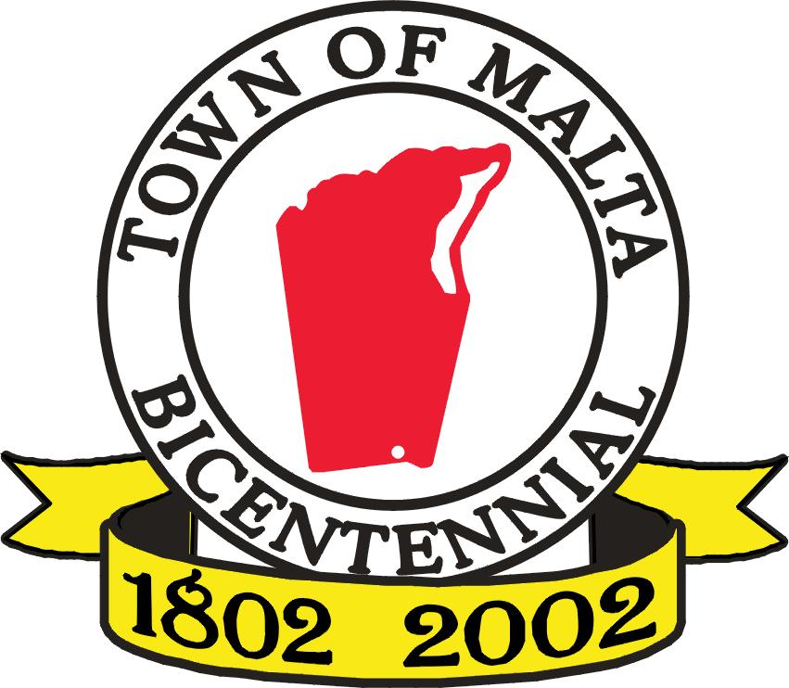
TOWN OF MALTA
Malta Summer Recreation Employment Application 2025

Name __________________________________________________________________
Street Address____________________________________________________________
Town________________________________State_____________Zip_______________
Home Phone ________________________Cell Phone____________________________
Email Address____________________________________________________________

Position Applied For: Summer Program (Half Day) _______ 9:00am-1:00pm
You must be 16 years old by July 1, 2025 to apply for the above program.
Dates of Employment: Monday, July 7, 2025-Friday, August 15, 2025

Employer Address Phone Supervisor
________________________________________________________________________
Position When Employed Reason for Leaving
________________________________________________________________________
Employer Address Phone Supervisor
________________________________________________________________________
Position When Employed Reason for Leaving
________________________________________________________________________
May we call or write the above supervisor? _______

REFERENCES This section must be completed in full.
Three references are necessary. Please fill in all the information completely.
Name Address Phone Position
1.______________________________________________________________________
2.______________________________________________________________________
3.______________________________________________________________________

Applicant’s Signature ___________________________________________ Date ________________
For employment in the Summer Recreation Program, this application must accompany the Saratoga County Application for Civil Service.

Office Use Application Received ______________________________Date of Interview ____________

Dear Malta Summer Recreation Applicant:

Attached to this letter is an application for employment in the Malta Summer Recreation Program for the summer of 2025. The half day camp begins on Tuesday, July 8, 2025 and continues until Friday, August 15, 2025. The basic hours are from 9:00am until 1:00pm with occasional extended hours for field trips. Orientation date is Monday, July 7, 2025. You must attend orientation.

Please complete the attached forms and return to me at
Barbara Mazurak, Malta Youth Director
David R. Meager Malta Community Center
One Bayberry Drive
Malta, New York 12020

When I receive the completed applications, I may contact you for an interview.
Please make sure that the reference information is filled in correctly with the name, address, and telephone number of the people that you are using as your references.

If you have any questions, please contact me at (518) 899-4411.

Sincerely yours,

Barbara Mazurak
Malta Youth Director

